Session II. Recommendations for Markers in Acute Coronary Syndromes
Introduction to Section II
1. The acute coronary syndrome (ACS) is a pathophysiologic continuum that results from rupture of an atherosclerotic plaque and an associated thrombus (55). It can ultimately result in clinical presentations ranging from entirely asymptomatic to unstable angina to massive acute myocardial infarction. ACS is the culmination of a series of events that begins with atherosclerosis, the narrowing of coronary arteries by deposition of highly lipid-filled plaque. (The etiologies, risk factors, and laboratory markers for atherosclerosis (lipoprotein metabolism, coagulation factors, agenetics, etc) are complex and beyond the scope of this monograph.) The American Heart Association have subdivided the plaque progression into distinct phases (56). Plaques formed in the early phases (I-III) are stable in that they have a thick fibrous cap, are not at risk for rupture, and the patient experiences no cardiac symptoms. However, for many patients, the plaque progresses to phases IV and Va which are lesions characterized by the thining of the cap and are vulnerable to rupture (Figure 4A). The fibrous cap can be thinned by inflammation and monocyte infiltration, activation of metalloproteinases, oxidation of LDL lipoproteins, augmentation of growth factors, and other processes. Shear stresses from diastolic blood pressure can lead to plaque ruptures in vulnerable areas such as the edges or shoulders of plaque lesions or bifurcations of the arterial tree (Figure 4B). The exposure of the core contents of lipids, cellular and extracellular elements (collectively termed “gruel”) results in thrombus formation and platelet aggregation, and the development of chest pain (Figure 4C). Incomplete occlusion of the coronary artery leads to unstable angina, while total occlusion lead to AMI (Figure 4D). Figure 5 summarizes the events and potential markers for each event that takes place after plaque rupture in acute coronary syndromes.
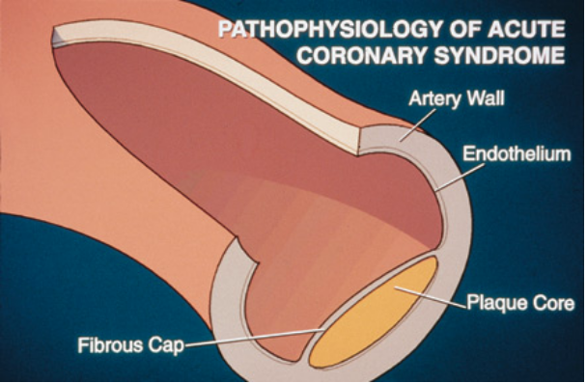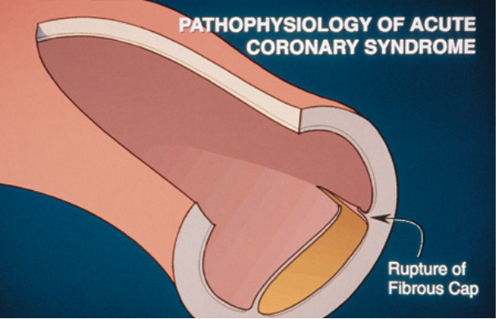
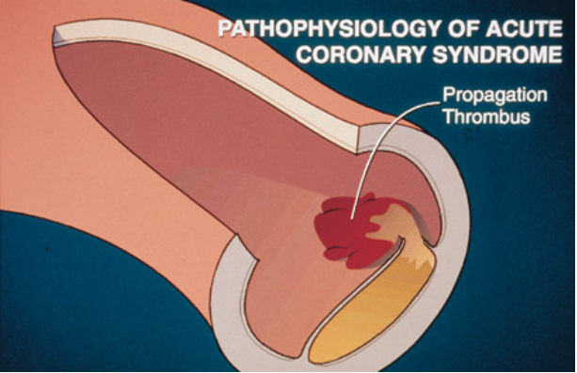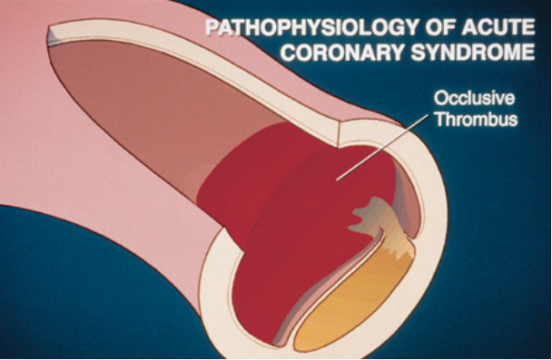

Fig. 4. Pathophysiology of acute coronary syndromes. A. Cross-section of coronary artery showing the presence of a lipid-filled plaque with a thin fibrous cap. B. Rupture occurring at the shoulder region of the plaque, which is an area of vulnerability due to high circulatory shear stress. C. Exposure of plaque core elements propagates thrombus formation. D. Totally occlusive thrombus causing AMI. Reprint from Clinical Laboratory News, Jun 1998, page 12-14, with permission from the American Association for Clinical Chemistry.

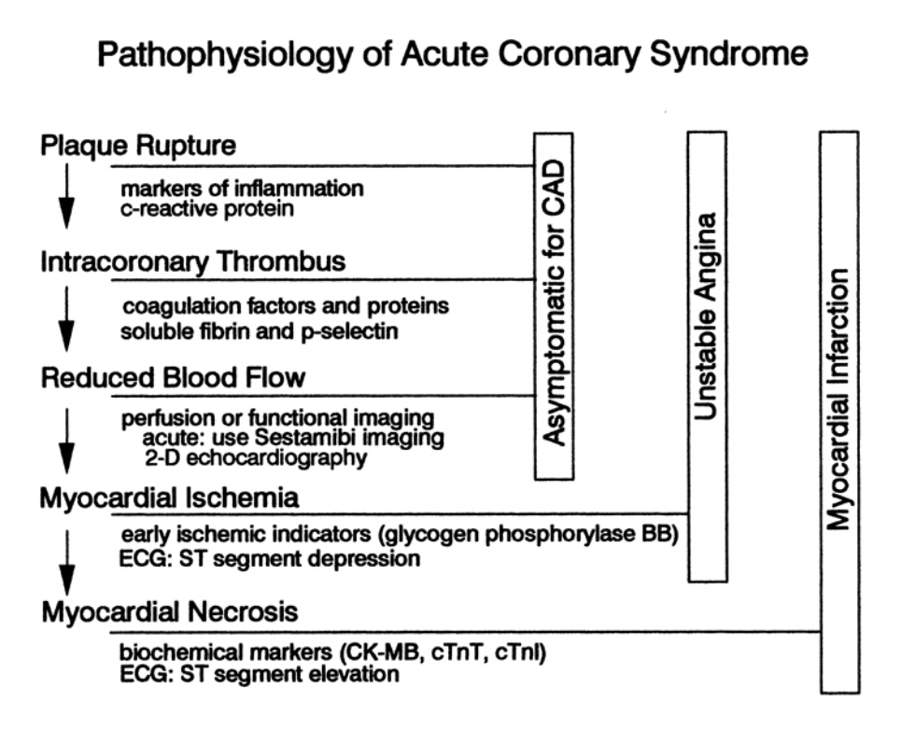
Fig. 5. Summary of pathophysiologic events in acute coronary syndromes. Reprint from Clinical Laboratory
News, Jun 1996, poster insert, with permission from the American Association for Clinical Chemistry.

Recommendation 1
The acute coronary syndrome is a pathophysiologic continuum that results from rupture of an atherosclerotic plaque, with subsequent platelet aggregation and thrombus formation (57,58). It can lead to clinical presentations ranging from entirely asymptomatic to unstable angina to AMI to sudden cardiac death attributable to arrhythmias. There have been major improvements in the specificity of new cardiac markers (such as cardiac troponin) and increases in analytical sensitivity for older markers such as CK-MB. When improved markers are compared to accepted standard markers, such as CK-MB, results that are discordant to each other can occur. For example, what does a positive troponin in a chest pain patient suggest when CK-MB is within the health-related reference interval? With improvements in the analytical sensitivity of these assays, it is now evident that small increases in sensitive markers such as cardiac troponin provide additional clinical information that is not evident with conventional enzyme markers.
Original validation studies for cardiac troponin assays have compared results against CK-MB for the diagnosis of AMI. When the upper limit of normal is used as the troponin cutoff concentration, clinical studies have shown that cardiac troponin was less specific for AMI diagnosis than CK-MB mass (59), using the classical WHO definition of AMI (43). This was because assays for cardiac troponin were detecting myocardial injury in some cardiac patients (e.g., those with unstable angina) with CK-MB below the cutoff (Fig. 3, peak C), and the extent of damage was insufficient to produce ECG patterns that were indicative of AMI. A higher troponin cutoff concentration could be used to mimic the clinical specificity of CK-MB for AMI. However, this choice will lead to the loss of clinically useful information because the importance of detecting myocardial injury (Fig. 3, peak D) has been demonstrated in retrospective outcomes studies in patients with abnormal concentrations of cTnT (60-62) or cTnI (63-65).
These studies define a population that is at high short-term risk (6 weeks) for adverse events (AMI and cardiac death). Cumulative meta-analyses suggest that the odds ratio for adverse events of a high troponin in unstable angina are 5:1 relative to a cohort of chest pain patients with normal troponin results (66). The risk is additive: the higher the cTnT and cTnI concentrations in blood, the higher the prospective risk (65,67). Thus, the detection of a low degree of myocardial injury is possible with the use of a low cutoff concentration for cardiac troponin (e.g., the upper limit of the reference interval), a strategy that is less applicable for nonspecific markers such as CK-MB.
The methodology for assignment of the low and high cutoff concentrations for cardiac troponin or any other cardiac marker is discussed in Session III under "Recommendation 5."

Recommendation: Two decision limits are needed for the optimum use of sensitive and specific cardiac markers such as cTnT or cTnI. A low abnormal value establishes the first presence of true myocardial injury, and a higher value is suggestive of injury to the extent that it qualifies as AMI, as defined previously by WHO (36).
Strength/consensus of recommendation: Class II.

Discussion
The concept of two decision limits for cardiac troponin was highly debated during the presentation of the Guidelines. A survey indicated that slightly more participants would prefer the use of a single cutoff concentration set at the lower of the two decision limits, rather than define two separate limits. No one suggested the use of a single cardiac troponin decision limit set at the AMI cutoff concentration. Many felt that the use of two limits overly complicates the situation and would require a substantial amount of physician education. Others felt that the therapeutic approaches for patients with unstable angina and non-Q-wave AMI are identical and that a differentiation between these two groups is, therefore, unnecessary.
The NACB Committee agreed with the consensus that detection of any myocardial injury was important (60), thereby justifying the use of a single low cutoff concentration for cardiac troponin. However, the Committee felt that use of a more sensitive cardiac marker (in a patient with a positive history of chest pain) would double the number cases of AMI compared with using the existing WHO criteria, which are based on the use of enzyme markers. It is important to not classify these patients as AMI, because they may be disadvantaged from a social, psychological, and socioeconomic standpoint (68). It may also affect how the hospital gets reimbursed for these services. Until the criteria for diagnosis of AMI are redefined by WHO or other clinical groups such as the American Heart Association or the American College of Cardiology, the NACB Committee recommends a two-cutoff designation for cardiac troponin; a low limit that detects a small amount of myocardial injury but classifies those patients at high risk, and a higher limit with the amount of injury present is to the extent that it conforms with a WHO-defined AMI. Figure 6 summarizes the selection of one cutoff concentration for a nonspecific biochemical marker such as CK-MB, and two cutoff concentrations for use of a specific biochemical marker such as the troponins (69).

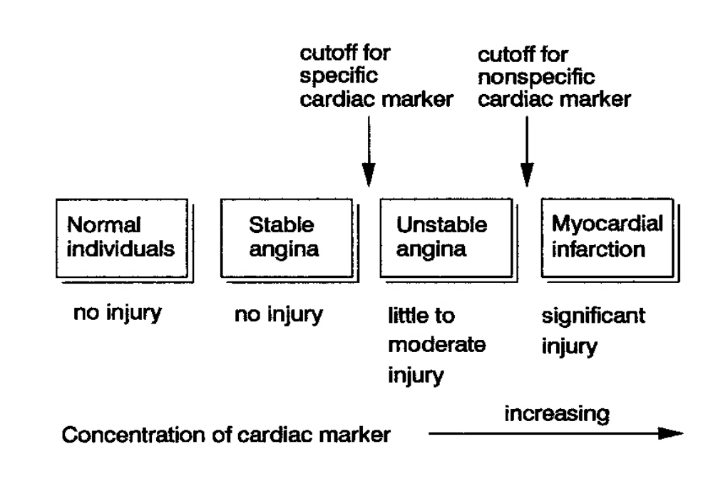
Fig. 6. Cutoff concentration for use of a non-specific marker such as CK-MB have traditionally been set
to differentiate between patients with unstable angina and AMI. Use of a biochemical marker that is highly
specific for cardiac injury enables the selection of two cutoff concentrations: differentiation between unstable
angina vs. AMI, and stable angina vs. unstable angina. Used with permission from Wu AHB, Clin Chim
Acta 1998;272:11-21.

Recommendation 2
In the past, CK-MB results between the upper limit of normal and the AMI decision limits had been termed the "gray zone." This practice was appropriate because CK-MB was not specific for the heart, and there were healthy subjects who had measurable CK-MB concentrations from skeletal muscle release within this range. The use of a low CK-MB cutoff would cause many of these patients to be incorrectly classified as having high cardiac risk. For cTnT and cTnI, the term gray zone should not be used because it connotes uncertainty in the clinical interpretation.

Recommendation: Chest pain patients with laboratory results for cTnT and cTnI between the upper limit of the reference interval and the decision limit for AMI should be labeled as having "myocardial injury.” These patients should be admitted and acutely treated to reduce the risks associated with this injury (60,61).
Strength/consensus of recommendation: Class I.
Discussion
In the original draft of these Recommendations and in some early literature reports on cardiac troponin [e.g., Ref. 72], abnormal troponin results occurring in some non-AMI patients with CK-MB within the reference interval were designated as having "minor myocardial injury or damage." The descriptive term, "minor' meant that the amount of tissue damage occurring to the heart was significantly less than that which occurs in patients with AMI. However, many conference participants felt that use of this term might be interpreted by physicians as minor risk for future untoward cardiac events, which is not true. In fact, unstable angina patients with abnormal concentrations of troponin may be at greater risk than surviving AMI patients because therapeutic options such as intravenous thrombolytic therapy are not available for the non-AMI patient. Other terms have been suggested that might better describe the clinical importance of this finding, such as "microinfarct"' or "infarctlet," or suggest that these patients have suffered a non-Q-wave AMI (73). Perhaps in some future clinical guideline, the term "acute myocardial infarction" can be eliminated entirely and replaced with "acute coronary syndromes." In this way, a single cutoff concentration for a cardiac marker such as troponin can be justified. This would reflect the incremental risks associated with increasing concentrations of the marker, consistent with the continuous injury concept of acute coronary syndromes.
In the current version of these Guidelines, the term minor has been removed. Excluding situations where the cardiac troponin was increased because of a problem with the assay's analytical specificity, all patients with an abnormal concentration of troponin have myocardial injury and should be viewed as having cardiovascular risk. It is the responsibility of the ordering physician to use this information in the context of other data in making the appropriate management decision.
It is also important to recognize that because troponin is increased for many days after AMI, it may be possible that without a full clinical history, small increases in troponin with a negative CK-MB might simply reflect an AMI in which CK-MB had returned to normal. Because of this fact, some might advocate keeping CK-MB mass assays available for this purpose. However, myoglobin could also fulfill this need because it would be normal in these late-presenting AMI patients. Myoglobin would might be available if the recommendations for two cardiac markers for ED triaging were followed by an institution.

Recommendation 3
WHO has defined the diagnosis of AMI as a triad (43). Two of which must be present for diagnosis:
i. The history is typical if severe and prolonged chest pain is present;
ii. Unequivocal ECG changes that are the development of abnormal, persistent Q or QS waves, and evolving injury lasting longer than 1 day; and
iii. Unequivocal change consisting of serial enzyme changes, or initial rise and subsequent fall. The changes must be properly related to the particular enzyme and to the delay time between the onset of symptoms and blood sampling.

With the development of biochemical markers that are not themselves enzymes, such as cTnT, cTnI, and myoglobin, the third criterion of the WHO triad should be revised.

Recommendation: The WHO definition of AMI should be expanded to include the use of serial biochemical markers and not be limited to enzyme changes. It should be emphasized that rule-out of AMI cannot be made on the basis of data from a single blood collection. However, when very specific cardiac markers are used, the presence of an abnormal concentration from a single specimen can be highly diagnostic of myocardial injury.
Strength/consensus of recommendation: Class I.
Discussion
The NACB Committee recognizes that clinical groups will have to lobby WHO to make substantive changes to their criteria for AMI diagnosis. This will require an international effort by cardiologists, emergency physicians, and laboratorians. Thus, the above recommendation is included to justify the use of myoglobin and cardiac troponin, and perhaps future non-enzyme protein markers that will have been shown to have value in the diagnosis of AMI.

Recommendation 4
The analysis of blood for lipids such as cholesterol and lipoproteins such as LDL and HDL is well established in the assessment of coronary artery disease risk (74). As such, these markers are being used to screen asymptomatic individuals. Because sensitive cardiac markers have also been shown to provide information on risk stratification, there may be an impetus to use these markers as part of a biochemical panel for routine health screening to detect the presence of silent ischemia, or after exercise stress testing to detect presence of ischemic injury. Studies of biochemical markers before and after nuclear ventriculography of chest pain patients have shown that neither cTnT or cTnI is increased after stress testing, even in patients with documented evidence of flow defects (75).

Recommendation: At this time, there are no data available to recommend use of cardiac markers such as cTnT or cTnI for screening asymptomatic patients for the presence of acute coronary syndromes. The likelihood of detecting silent ischemia is extremely low, and cannot justify the costs of screening programs. Additionally, there is also no evidence that cardiac marker analysis of blood following stress testing can indicate the presence of coronary artery disease.
Strength/consensus of recommendation: Class III (for use of cardiac markers for screening).

